Current State

Aesthetics kept simple. Interaction via left hand ribbon with the various pages in the application. Can move this ribbon anywhere (right, center, bottom, etc). Filters may be on the top through dropdowns as well. Additionally, you can also go between different graphics using the Lab Count, Lab Pct, etc tabs across the top. Currently keeping the color schemes simple. Graphs and KPI’s shown on the top. Tables are being used to show detailed item data.

What I Need from You

* Review the current state screen shots below and decide what looks good, what doesn’t look good, how you would like to see/interact with things
* Also, please look at the ‘Examples’ below of other web applications built using the same programming language.
* Lastly, please review the link directly below and scan the page for visual examples of theming and aesthetic examples.
* Please include an feedback in a copy of this document sent back to me, at [tsonger@gmail.com](mailto:tsonger@gmail.com)

<https://shiny.rstudio.com/articles/themes.html>

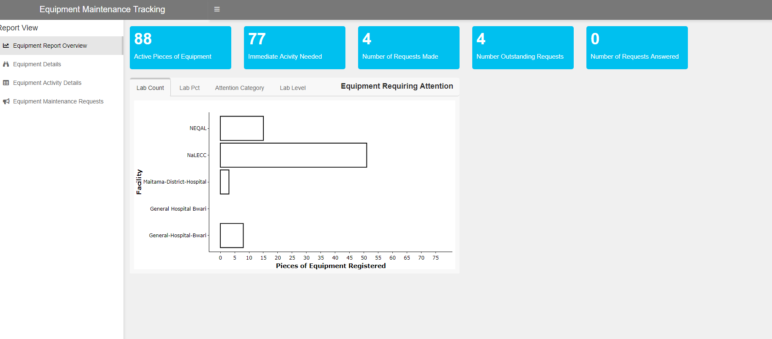

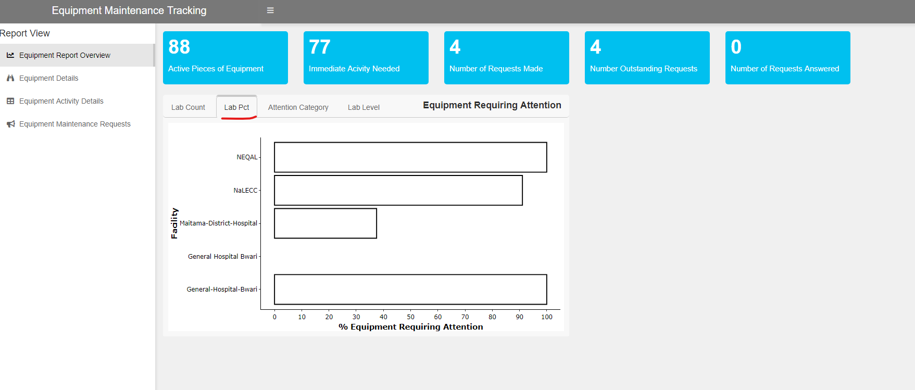

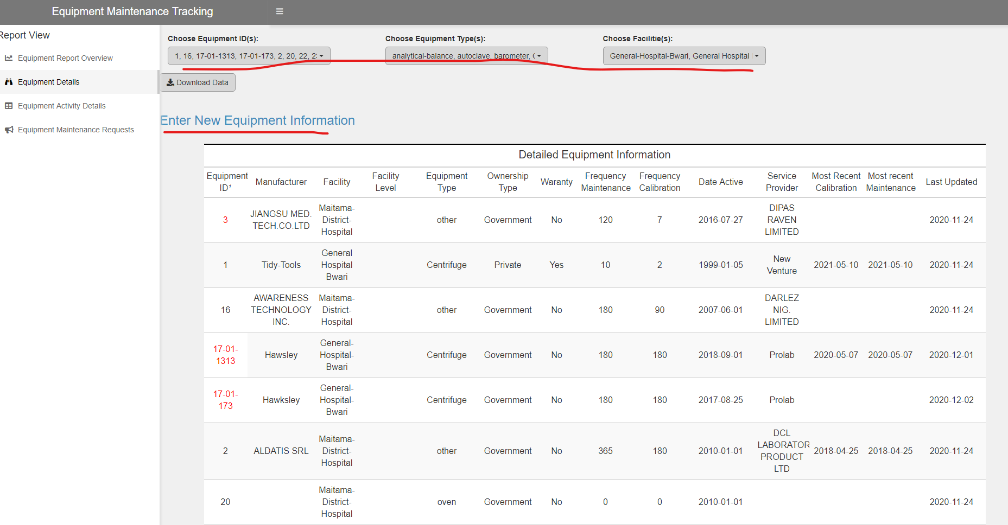

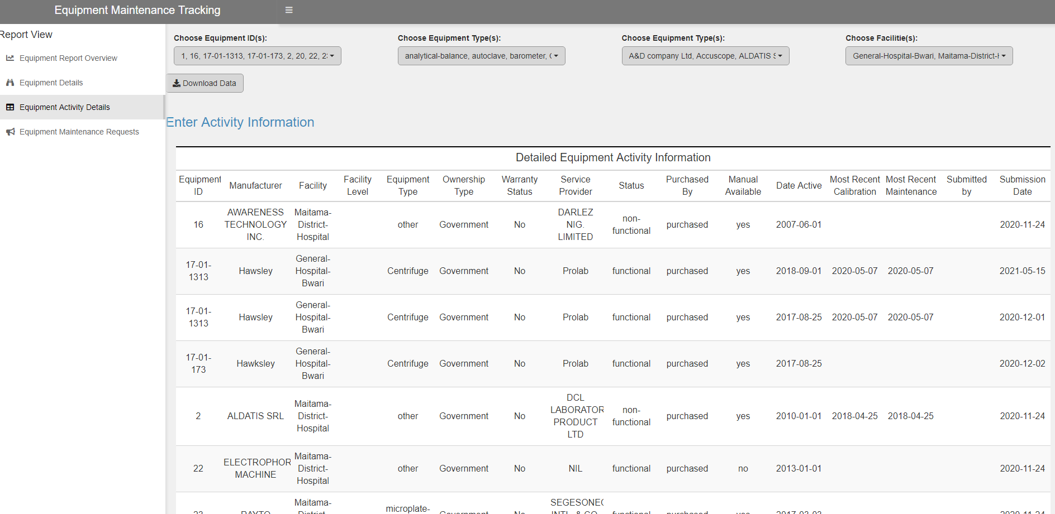

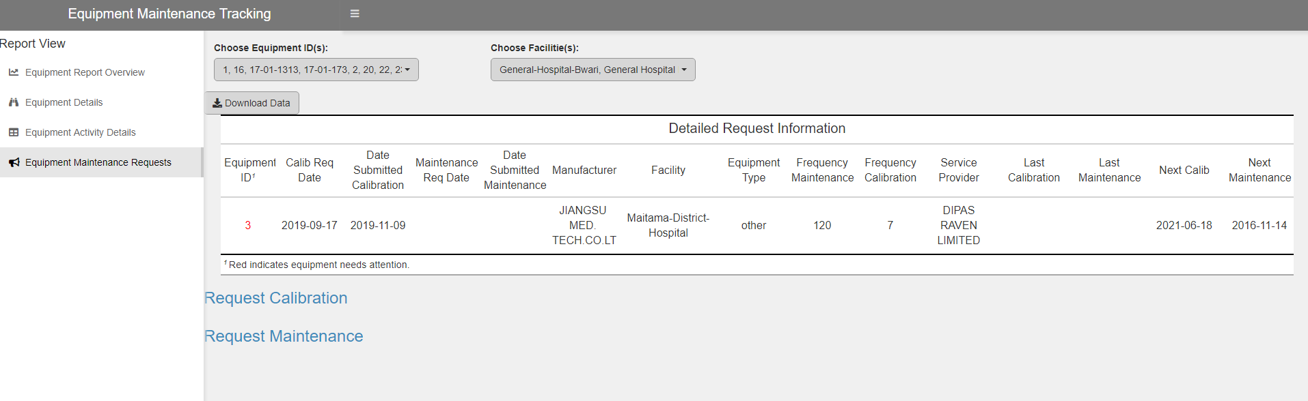

Examples

